Figure test

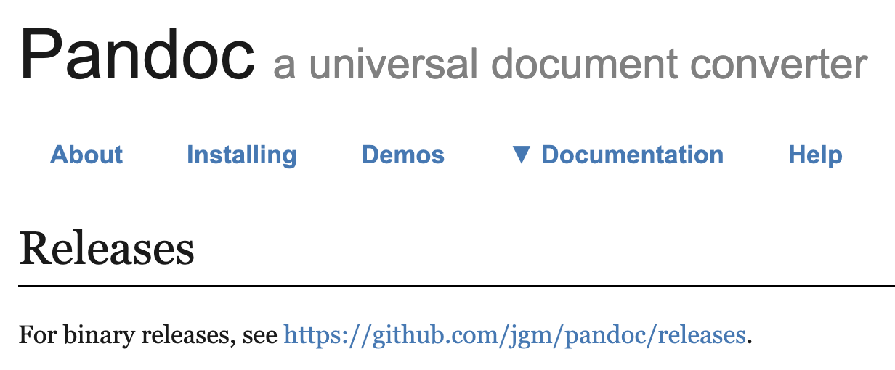
Figure 1 A figure caption

